Chat Application Simulator

Requirements Document
Table of Contents

1 Introduction 3
1.1 Purpose and Scope 3
1.2 Target Audience 3
1.3 Terms and Definitions 3
2 Product Overview 4
2.1 Users and Stakeholders 4
2.1.1 Client User 4
2.1.2 Server User 4
2.2 Use cases 4
2.2.1 Client Login 4
2.2.2 Client Chat 4
2.2.3 Access of Records 4
3 Functional Requirements 5
3.1 Login User 5
3.1.1 Login User Aspects 1 5
3.1.2 Login User Aspect 2 5
3.2 Connect to Chat Server and Chat with users 5
3.3 Access of Chat Records 5

4 Nonfunctional Requirements 6
4.1 Storage of Accounts and Online Users 6
4.1.1 Storage of User Account 6
4.1.2 Storage of Online Users 6
4.2 Max number of Users 6
4.3 Server Response Time 6

5 Milestones and Deliverables 7
5.1 Login and Connection Setup Milestone/Deliverable 1 7
5.1.1 Login Milestone/Deliverable 1 Stage 1 7
5.1.2 Milestone/Deliverable 1 Stage 1 7
5.2 Milestone/Deliverable 2 7

Introduction
This is a scope of the Requirements needed for the Chat Application. This chat application consists of a chat server and multiple client users. The server accepts connections from clients and delivers all the message in-between the users. This is a two-way communication tool.

Purpose and Scope
The purpose of this document is to give a broad overview of all the initial requirements the chat application needs. It covers all the tasks that the program must provide. The purpose of the program is to communicate with multiple people at the same time.

Target Audience
This document directed towards developers and client. It specifies the requirements and functionality the program will need to feature in order to meet the client’s demands. This document has use case diagrams that helper both the developer and client to understand the process.

Terms and Definitions
User- A client that uses the chat application.
Client- The chat handler for a user. The user interface and communication
Server- A server that accepts connections from clients and directs all communication
Record- A text file record of a user’s chat history
Account- An account that stores username and password for the user.

Product Overview
The chat application consists of a server and clients. Users login into the client program and the server accepts connections from the client. Server than broadcasts messages to all the clients or an individual user. Users have the option to access personal chat log records.

Users and Stakeholders
People that connect to the Client chat server are the users. They communicate with other users.

Use cases
The use cases below are designed to give a clear overview of all the components and tasks of the chat application. Each use case deals with a specific action a user or server will perform. These allow for quick explanations and modifications.

Client Login Use Case
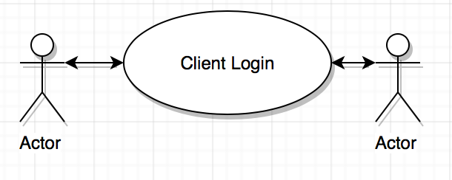
Brief Description: In order to chat the user must login or register for an account. Once the user has logged in they will be given access to the chat server. An initial login screen will verify user details and give access to the user.
Step by Step Description
- User will be greeted by a Login screen where they will have to enter details.
- Server will than verify account details and either let user in or deny the request.
- If access is denied, the user will need to register and the account details will be added to the server.

Client Chat Use case 2
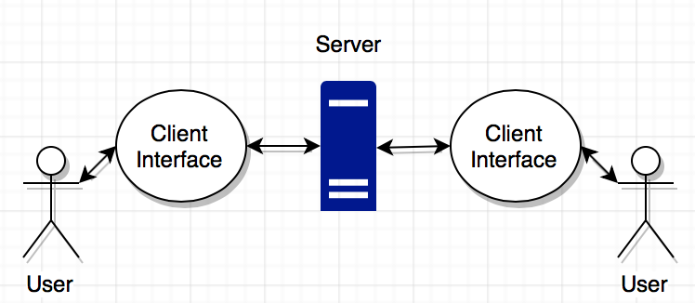
Brief Description: Server accepts connections from clients and delivers all messages from each client to other clients or private chat if user wants. Server is constantly accepting new connections and generates a list of connected users.
Step by Step Description
- After login, user will be given a client chat interface and will connect to server.
- Server will simultaneously read messages from clients and broadcast them.
- Server will simultaneously generate records of all messages sent.
- Users will have ability to enter a private chat with any online user.

Access Records Use Case
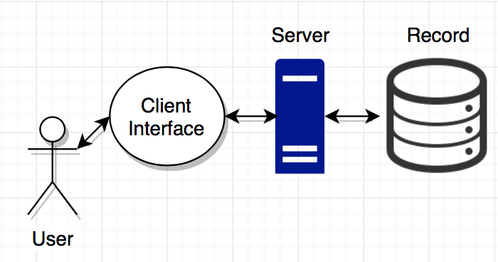

Brief Description: Access Record Use case enables the client user to access its record of all chat messages sent. The server records all traffic communication for a user and stores it into a small database. The client interface will have a button the user can press to access those records.

Functional Requirements
The purpose of this section is to identify all the actions that the chat application must be able to perform. These are expressed in terms of the client accessing the server and sending information to other clients. Most of the functions are requested from the clients needs.

Login Client
The User(Actor) must log in first before they can communicate with the server or other users. A login screen will be presented to allow the user to enter account details or register for a new account. Once logged in they will be given access to the server

Login User GUI 1 Aspects 1
A graphical user interface will be created with fields and button to allow the user to interact. This Login application must establish a connection with the server to access database of users. The application will take input and send it to the server

Login User Account Validation 1 Aspect 2
After the user has entered their details, the server has to take that information and validate that a account exist with that username. If it exists, the Server will present the user with a new chat interface and be logged in. If not the user will have to either register or close application. Once logged in they Server will register the account as online and the user will be allowed to chat with other clients online.

Connect to Chat Server and Chat with users
Brief Description: Server accepts connections from clients and delivers all messages from each client to other clients or private chat if user wants. Server is constantly accepting new connections and generates a list of connected users.
Step by Step Description
- After login, user will be given a client chat interface and will connect to server.
- Server will simultaneously read messages from clients and broadcast them.
- Server will simultaneously generate records of all messages sent.
- Users will have ability to enter a private chat with any online user.

Access of Chat Records
Brief Description: A user accessing the client chat program will have a button to access the all their chat logs from the conversation. The server store and maintain the chat records for each user.
Step by Step Description
- After login, user will be given a client chat interface and will connect to server.
- User will click “Show Records” button next to the send button.
- Server will look and try to fetch the records for that particular user.
- A new window will appear and will display the users chat records

Nonfunctional Requirements
These requirements are properties of the chat application such as constraints and reliability.

Storage of Accounts and Online Users
The Chat application also has a task of storing all the user accounts and specific online users in order to be able to send messages and store things correctly. There needs to be tow separate list in order to keep track of online/offline user accounts. Only online users can have access to all the chat features.

Storage of User Account 1 Aspects 1
In order to Login with an Account, there has to be a list of some type to store all the users. From this database, The Login Client can connect to the server and access all the records to verify information.

Storage of Online Users 1 Aspect 2
The Server will also have to have a separate storage of all the online users. Without this there is no way of sending all the messages correctly If we don’t know who is online. This is a separate list from the User accounts and its job is to only keep track of active users.

Max Number of Users
Max number of users will be based upon how much the server can handle. At a bare minimum the chat should support up to 10 users at the same time.

Server Response Time
The user’s internet connection will determine the speed for how quickly messages get delivered. Server should be optimized to handle multiple connection and sync properly.

Milestones and Deliverables
The purpose of milestones is to set checkpoints and try complete the program in phases. With each milestone, more components are added and tested. Milestones allow us to test and make changes if something goes wrong. Each milestone has a certain purpose and goal that it tries to complete. The chat application can be split into milestones to start developing its main components.

Login and Connection Setup Milestone 1
This milestone will consist of building and testing the graphical user interface that the user will use to login. All buttons and Text input should be working. The Login client should make a connection with the server.

Server/Client Setup Milestone/Deliverable 1 Stage 1
This milestone will consist of created the Chat Server that will server all the clients connected. Server should also have storage of all the user accounts and be able to add or modify them. The client program should be able to connect to the server and send information across.

Server/Client Messaging Milestone 2
This milestone will consist of the Server reading and writing information from the Client servers. Clients should be able to message everyone or a single individual. Messages should be logged and recorded for each individual user.

Closing Connections Milestone/Deliverable 3
At this milestone all the core components should be working and delivering messages. The main focus of this milestone is having everything closed properly and all connections be determined. All the information sent across the server between the clients should be stored and ready for next use.

